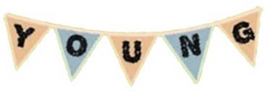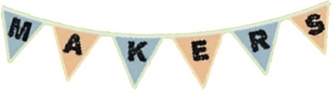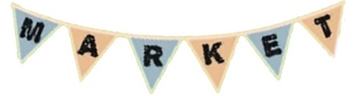

Registration Form
YOUNG MAKERS’ MARKET – 20th December 2019
Please fill in the following:
Name(s)
Stall Name
Age(s)
Contact Number
Emergency Contact | Name: | Phone Number: | Relationship to you:
Email
Township?
What are you selling?

Please circle YES or NO for each of the following options:
I would like to rent 1 of the available 8 marquees for $5 if possible. | YES | NO
I am bringing a marquee of my own. | YES | NO
I will not be using a marquee. | YES | NO
I would like to rent a table for $5. | YES | NO
I am bringing a table of my own. | YES | NO
I would like access to electricity for $5. | YES | NO

Please turn over for more details

Please indicate anything else you think we might need to know about you and anything you would like to know about us or the market in the section below (optional):

Things we might need to know about you? (medical conditions, stall specification, etc.)

Things you would like to know about us or the market?

Please return completed forms to youngmakersmarket@outlook.com or drop off at Mount Alexander Shire Council Customer Service desk

Thanks
Young Makers Market Committee

