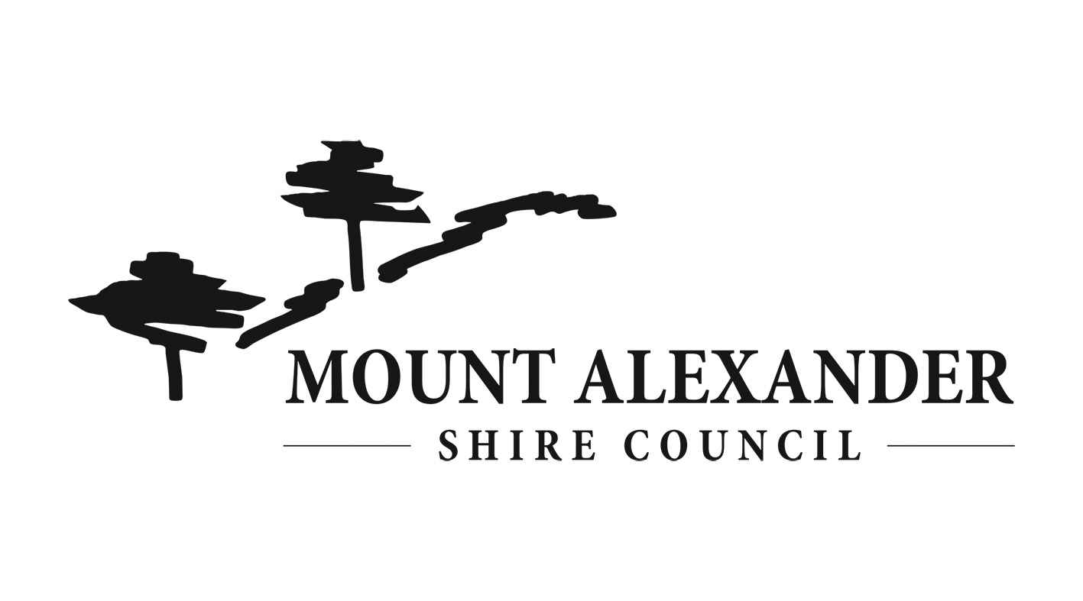Entry Form

Pop-up Art Café 2021

WHAT IS THE POP-UP ART CAFE?

The Pop-up Art Café is being run by Council’s Youth Advisory Group as part of Victorian Youth Week to promote and support young local artist. A youth art exhibition will be opened from 29 June – 9 July 2021. The exhibition will be launched on 29 June along with a pop-up youth run café.

GUIDELINES FOR ART

- Eligibility
To enter you must be:
- Age 12-25 years
- Live, work, study or recreate in Mount Alexander Shire
Only one piece of art can be submitted per person.

- Submission Deadline
Entries must be submitted by 22 June 2021.

- Type of artwork
- 2D artwork that can be hung. Could be a painting, drawing, photography, print etc.
- Must be your own work
- Maximum size is A1 (59.4cm x 84.1cm)

- Installation
Your artwork must be ready to be hung, so must be framed or mounted with hanging mechanism.

- Consent
If you are entering a photograph you must have the consent of the subject in the photo.

ARTIST PAYMENT
Artist will be provided with a small payment for their participation.

SELECTION CRITERIA
There are a limited amount of places in the exhibition. Selection will be based on:
- Artistic and creative excellence
- Technical difficulty
- Challenging use of materials
- Imaginative quality
- Originality
- Compatibility with the space

DESCISION MAKING
The selection panel will comprise of representatives from Mount Alexander Shire’s Youth Advisory Group. All applicants will be advised of the outcome of their submission.

HOW TO ENTER?

Email your Entry Form to youth@mountalexander.vic.gov.au along with a photo of your artwork.

For more information on the Pop-up Art Café or for help with submitting your Entry Form, contact Shannon Lacy on 5471 100 or youth@mountalexander.vic.gov.au
ENTRY DETAILS

ARTWORK TITLE: ………………………………………………………………………………………………………
DESCRIPTION: (Optional. This will be displayed with your artwork. 100 words max.)
i.e. materials used, concept, meaning, inspiration.

……………………………………………………………………………………………………………………….
……………………………………………………………………………………………………………………….
……………………………………………………………………………………………………………………….
MEDIUM:
……………………………………………………………………………………

ARTIST
NAME: ………………………………………………………………………………………………………….
AGE: …………………. TOWN:
CONTACT PHONE NO: ……………………………………………………
CONTACT EMAIL:

Do you want your name displayed with your artwork?
Yes No

Do you want to offer your artwork for sale during the exhibition?
Yes No
If yes, how much would you like to sell your artwork for?
……………………………….

Privacy Statement:
Mount Alexander Shire Council collects this information for the purposes of processing and considering your entry to the Pop-up Art Café 2021. We will use the information we collect from you only for these purposes and will not disclose personal information unless authorised by you or as permitted or required by law. Your information is treated as confidential and managed in accordance with Council’s Information Privacy Policy.

