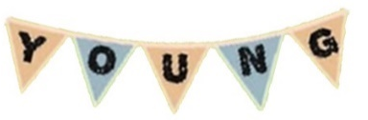

Registration Form - December 18th 2021
If you are unsure about any of the details you are being asked to provide in the form, please feel free to contact us by email at youth@mountalexander.vic.gov.au or call at 0429 421 214.
Please fill in the following:
Name(s):
Stall Name:
Age(s):
Contact Number:
Email:
Township:
What are you selling?
Emergency Contact Information | Name:
 | Phone Number:
 | Relationship to you:

Please circle YES or NO for each of the following options:
I would like to rent 1 of the available marquees for $5 if possible. | YES | NO
I am bringing a marquee of my own. | YES | NO
I will not be using a marquee. | YES | NO
I would like to rent a table for $5. | YES | NO
I am bringing a table of my own. | YES | NO

Please indicate anything else you think we might need to know about you, or anything you would like to know about us or the market in the section below (optional):
Things we might need to know about you… (medical conditions, stall specification, etc.)

Things you would like to know about us or the market…

Please return completed forms to youth@mountalexander.vic.gov.au or drop off at Mount Alexander Shire Council Customer Service desk

Thanks
Young Makers Market Committee

