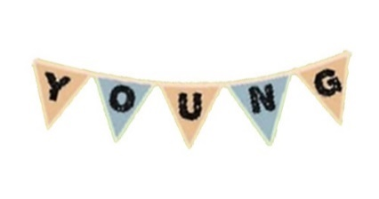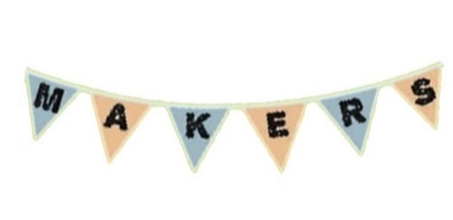

YMM Registration Form - Sunday 22 SEPTEMBER 2024

If you are unsure about any of the details you are being asked to provide in the form, please feel free to contact us by email at [youth@mountalexander.vic.gov.au](mailto:youth@mountalexander.vic.gov.au) or call at 0429 421 214.

**Please fill in the following:**

|  |  |  |
| --- | --- | --- |
| Name(s): |  | |
| Stall Name: |  | |
| Age(s): |  | |
| Contact Number: |  | |
| Email: |  | |
| Township: |  | |
| What are you selling? |  | |
| Emergency Contact Information | **Name:** |  |
| **Phone Number:** |  |
| **Relationship to you:** |  |

**Please circle** YES **or** NO **for each of the following options:**

|  |  |  |
| --- | --- | --- |
| I would like to rent 1 of the available marquees for $5 if possible. | **YES** | **NO** |
| I am bringing a marquee of my own. | **YES** | **NO** |
| I will not be using a marquee. | **YES** | **NO** |
| I would like to rent a table for $5. **(x2 tables & x2 chairs provided per booking)** | **YES** | **NO** |
| I am bringing a table of my own. | **YES** | **NO** |

**Please indicate anything else you think we might need to know about you, or anything you would like to know about us or the market in the section below (optional):**

*Things we might need to know about you… (medical conditions, stall specification, etc.)*

*Things you would like to know about us or the market…*

**Important Safety Considerations:**

* In the event of high wind speeds on market day, marquee use may be withdrawn due to safety reasons
* In the event that the temperature is forecast for 36 degrees Celsius or higher, the event **may** be cancelled
* In the event of a heavy rain event of 4mm-8mm per hour, or forecast for thunderstorms, the event **may** be cancelled
* Young people under the age of 12 years old need to be supervised by a parent / carer

**Please fill out the Film and Photo Consent Form on Page 3 before returning your completed application. If you have already completed a Film and Photo Consent Form from a previous market, you are not required to do so again.**

Please return completed forms to [youth@mountalexander.vic.gov.au](mailto:youth@mountalexander.vic.gov.au) or drop off at Mount Alexander Shire Council Customer Service desk

*Thanks ☺*

*Young Makers Market Committee*

This Consent Form constitutes your permission for Mount Alexander Shire Council to utilise photographs and film footage taken of you for the purposes of promoting Mount Alexander Shire Council through any media.

1. Your details

Name ______________________________________________________________

Address ____________________________________________________________

Postcode ____________________________ Phone no_______________________

2. Granting of consent

I hereby grant permission to Mount Alexander Shire Council, the right to use photographs & film footage taken of me, without restriction, for the purposes of promoting Mount Alexander Shire Council, through any media.

Signature _____________________________________________________________

Date________________________________

**If under 18 years of age:**

Name of parent or responsible adult ________________________________________

Parent/ guardian signature ________________________________________________

Date _______________________________

**Privacy Statement:**

Mount Alexander Shire Council will use the information we collect from you only for these purposes. Your information is treated as confidential and managed in accordance with Council’s Information Privacy Policy.

Please return completed forms to **Jodie** by emailing [youth@mountalexander.vic.gov.au](mailto:youth@mountalexander.vic.gov.au), or dropping them in at Mount Alexander Shire Customer Service on Lyttleton/ Lloyd St.

Mount Alexander Shire Council

Photo and Film Consent Form