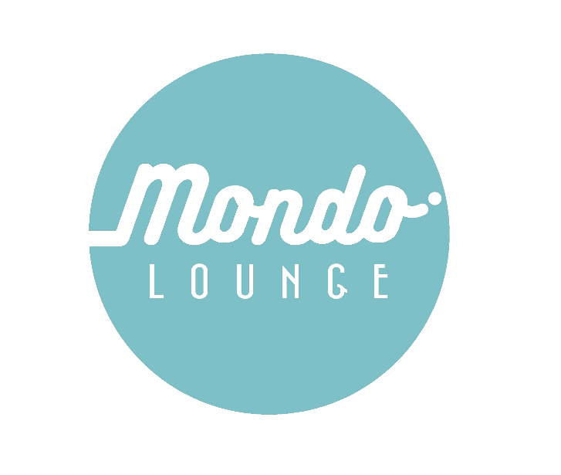
Mondo Lounge Parental Consent and Medical Form

Program/Activity name: Mondo Lounge Youth Space and/or Youth Programs
Participant name: __________________________________________
Address:______________________________________
Suburb:_________________ Postcode:_____________
D.O.B: ________________________________
Female Male Non-binary or gender diverse
Preferred Pronouns:________________________

Parent/Guardian name:______________________________________
Address: ________________________________________________________________________
Telephone (H) ________________ (M)____________________(W)_____________________
Email address (if you would like to be kept updated with Mondo Lounge activities): _______________________________________________________________________

Please read the following and sign the agreement below.
I (and my child) agree and understand that:
Mondo Lounge operating times:
- During school terms on:
  - Wednesday’s from 3.30pm-6pm for secondary school students, aged 12-14 years;
  - Friday’s from 3.30pm-6pm for ages 15-18 years.
- During school holidays and one-off programs (dates and times communicated to parents as needed)

The program and all associated activities will be supervised.

Whilst all efforts to maximize the safety of participants, I/my child attends the program and activities entirely at my/his/her/their own risk, and must exercise due care to ensure his/her/ their personal safety and that of others.

I have no medical or physical condition that may be made worse by participation in the program and activities (If so, please outline on the medical form).

Whilst all efforts are made to maximize the safety of possessions, Mount Alexander Shire Council will not be responsible for any personal items which are stolen or damaged during the course of any activity, training or excursion.

I will conduct myself in a safe, responsible and respectful manner for the duration of the program and all associated activities.

I will follow any direction or advice affecting my or others safety or wellbeing given to me by staff.

I will pay for any associated costs (medical, transport etc) that arise due to unforeseen circumstances, incidents or an accident.

I consent to my child engaging with (M) rated movies, music and video games, at the discretion of the Youth Activities Officer, while participating in Mondo Lounge activities.

Young people attending a Wednesday session for ages 12-14 years are required to remain at the program once signed in. Once a young person signs out they are not able to return. Young people attending the program on a Wednesday must sign in prior to 5pm.

I hereby consent and agree to the Mount Alexander Shire Council using my/ my child/s photograph or film likeness for promotional or training purposes.

Mondo Lounge Youth Space will close at 6pm and staff will not be present for supervision from 6.15pm.

I acknowledge I am responsible for my child’s travel to and from the Mondo Lounge and all associated activities.

This form must be completed and returned prior to your child/ren attending a Mondo Lounge program.

In the event of weather forecasting 36 degrees or above, Mondo Lounge programs will be closed.
In the event of an Extreme fire danger day where the Fire Behaviour Index (FBI) exceeds 75 or a fire danger rating of catastrophic, Mondo Lounge programs will be closed.
Parents/Carers will be notified via text if a closure happens.

I have read this indemnity agreement and I fully understand its contents.
Signed (Participant): _______________________________ Date: _____________
Signed (Parent/Guardian): _____________________________ Date: _____________
(NOTE: To be signed by a parent/guardian and the person participating in the program/activity. If the participant is 18 years old or over – the parent/guardian is not required to co-sign form).

All participants must also complete the following:

Participant Medical Details

Name:_________________________________
Medicare Number:______________________________ Expiry:_______________
Doctors Details (Name):_________________________ Address:__________________________________ Phone:__________________________
Detail any specific dietary requirements you have:
__________________________________________________________________________________
Any other considerations or support to attend this program:
__________________________________________________________________________________

Primary Emergency Contact
Name:_________________________________________ Relationship:____________________________Phone:________________________________ Alternative phone: ________________________________
Address:__________________________________ Suburb:__________________ Postcode: _______

Alternative Emergency Contact
Name:_________________________________________ Relationship:____________________________Phone:________________________________ Alternative phone: ________________________________
Address:__________________________________ Suburb:__________________ Postcode: _______

Medical conditions, illnesses, or specific considerations
This could include things like neurodiversity, mental health considerations, behavioral needs or any access and inclusion requirements. Understanding this information will help us provide the best possible support to help your child participate in a meaningful way.

No Yes, please give details or speak to a staff member directly for further support:
____________________________________________________________________________________________________________________________________________________________________

Allergies
Do you have any known allergies? No Yes, if yes please provide details and treatment:
____________________________________________________________________________________________________________________________________________________________________

Asthma
Do you suffer from asthma? No Yes, please provide details and treatment:
____________________________________________________________________________________________________________________________________________________________________

Medications
Are you currently taking any form of medication? No Yes, If yes, please provide details:
__________________________________________________________________________________
_________________________________________________________________________________
If appropriate, this medication must come away on events and activities

I agree to my child's attendance at the above mentioned programs. In the case of an emergency, I authorise the program staff, where it is impracticable to communicate with me, to arrange for my child to receive such medical or surgical treatment as may be deemed necessary. I also undertake to pay or reimburse costs which may be incurred for medical attention, ambulance transport and other medications while my child is enrolled with the program. I understand that although the organisation tries to minimise any risk of personal injury within practical boundaries, accidents do happen and all physical activities carry the risk of personal injury. I acknowledge that there is an inherent risk of personal injury in physical activities that will be undertaken as part of this program.

Parent/Legal Guardian signed: _____________________________ Date: __________________

Please Print Name:____________________________________________

Privacy Statement:
Mount Alexander Shire Council collects this information for the participation of your child at Mondo Lounge activities. We will use the information we collect from you only for these purposes and will not disclose personal information unless authorised by you or as permitted or required by law. Your information is treated as confidential and managed in accordance with Council’s Information Privacy Policy. Failure to provide some or all of the information requested may result in exclusion from the excursion. You may access or update this information by contacting Mount Alexander Shire Council on 03 5471 1700.


Transport Consent Form

What: Mondo Lounge Activities and Excursions
When: Activity and excursion times/ dates may vary depending on the program. A note detailing activity, time, date and general information will be issued to parents/ guardians a week prior to scheduled activity.
Contact: Youth Development Team, Mount Alexander Shire Council.
Ph: 5471 1700 e: youth@mountalexander.vic.gov.au

Contact Information
Participant Name:
Parent/Guardian Name:
Relationship to participant:
Phone: | Mobile:
Declaration
The following must be read carefully and signed by a parent or guardian.

I, the undersigned, authorise the Mount Alexander Shire Council Officers, to transport my child to and from Mondo Lounge activities and excursions via Council bus or car, hired transport or public transport.
Print name:
Signed: Date:

