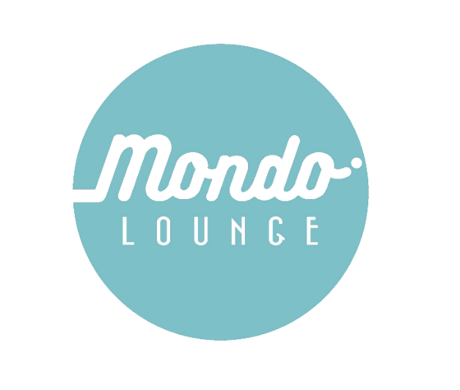
Mondo Lounge One-Off Program

Parental Consent and Medical Form

What: 4-week Event Mountain Biking Workshop
When: Thurs 28 May – Thurs 25 June
Where: Walmer State Forest

Contact: Rob Saxton, Youth Activities Officer, Mount Alexander Shire Council.
Ph: 0468 573 148 e: youth@mountalexander.vic.gov.au

Participant information
Child Name:
Pronouns:
Age:
Participant medical details
Medicare Number: Expiry:
Doctors Details (Name and address):
Medical conditions, illnesses, or specific considerations
This could include things like neurodiversity, mental health considerations, behavioral needs or any access and inclusion requirements. Understanding this information will help us provide the best possible support to help your child participate in a meaningful way.
No  Yes, please give details or speak to a staff member directly for further support

Do you have any known allergies? No Yes, please provide details and treatment:

Do you suffer from asthma? No Yes, please provide details and treatment:

Are you currently taking any form of medication that we need to be aware of? No Yes, please provide details:

Are there any other considerations to attend this program / workshop?

Please turn over

Emergency contact (please provide 2)
1st emergency contact: | 2nd emergency contact:
Name: | Name:
Relationship to participant: | Relationship to participant:
Phone: | Phone:
Alternative phone: | Alternative phone:
Declaration
The following must be read carefully and signed by a parent or guardian.
- I, the undersigned, agree to my child participating in 4-week Event Photography Workshop between 28 May – 25 June, 2026.
- I authorise the Mount Alexander Shire Council Officers, to transport my child to and from the Walmer State Forest via Council vehicle, bus or car.
- In the case of an emergency, I authorise the program staff, where it is impracticable to communicate with me, to arrange for my child to receive such medical or surgical treatment as may be deemed necessary.
- I also undertake to pay or reimburse costs which may be incurred for medical attention, ambulance transport and other medications while my child is enrolled with the program.
- I understand that although the organisation tries to minimise any risk of personal injury within practical boundaries, accidents do happen and all physical activities and training courses carry the risk of personal injury.
- I acknowledge that there is an inherent risk of personal injury in physical activities that will be undertaken as part of this program.
- Do you authorise Mount Alexander Shire Council to use your child’s photographed or recorded image for promotional purposes? YES NO
- Would you like to be kept updated with Mondo Lounge / youth activities? YES NO

Email: _______________________________________________

Print name:
Signed: Date:

Privacy Statement:
Mount Alexander Shire Council collects this information for the participation of your child at Mondo Lounge activities. We will use the information we collect from you only for these purposes and will not disclose personal information unless authorised by you or as permitted or required by law. Your information is treated as confidential and managed in accordance with Council’s Information Privacy Policy. Failure to provide some or all of the information requested may result in exclusion from the excursion. You may access or update this information by contacting Mount Alexander Shire Council on 03 5471 1700.

